**Spesifikasi Kemasan**

**Nama Produk :** ZOI Ilios 5000 Series Surgical Light - Double Dome dengan Hanging Monitor dan Built-in Camera

**Tipe :** ZOI-SL-IL-5200

1. **Label**
   1. Label penandaan ZOI Ilios 5000 Series Surgical Light - Double Dome dengan Hanging Monitor dan Built-in Camera

* Bahan : Stiker Vinyl
* Warna Label : Putih
* Warna Teks : Hitam
* Ukuran : 90 x 60 mm (p x l)

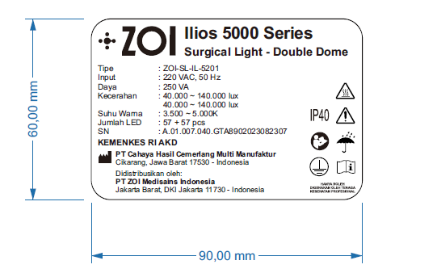

Gambar 1. Label Penandaan ZOI Ilios 5000 Series Surgical Light - Double Dome dengan Hanging Monitor dan Built-in Camera

1. **Kemasan**
   1. Wooden Box ZOI Ilios 5000 Series Surgical Light - Double Dome dengan Hanging Monitor dan Built-in Camera
      * Bahan : Kayu
      * Bentuk : Kotak
      * Warna : Natural/kayu/Coklat
      * Ukuran : 115 x 115 x 85 cm (p x l x t)

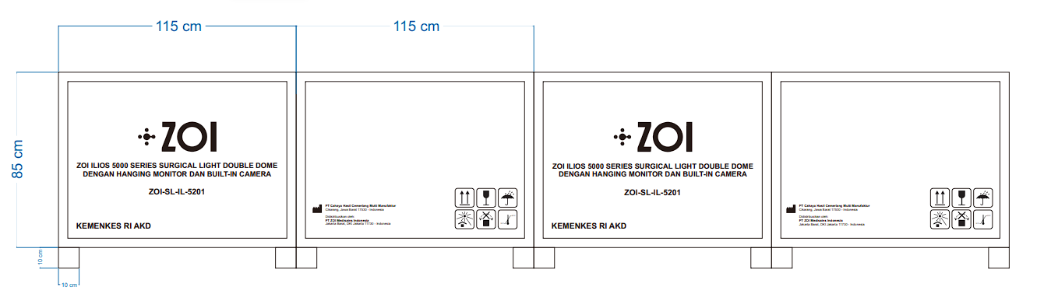

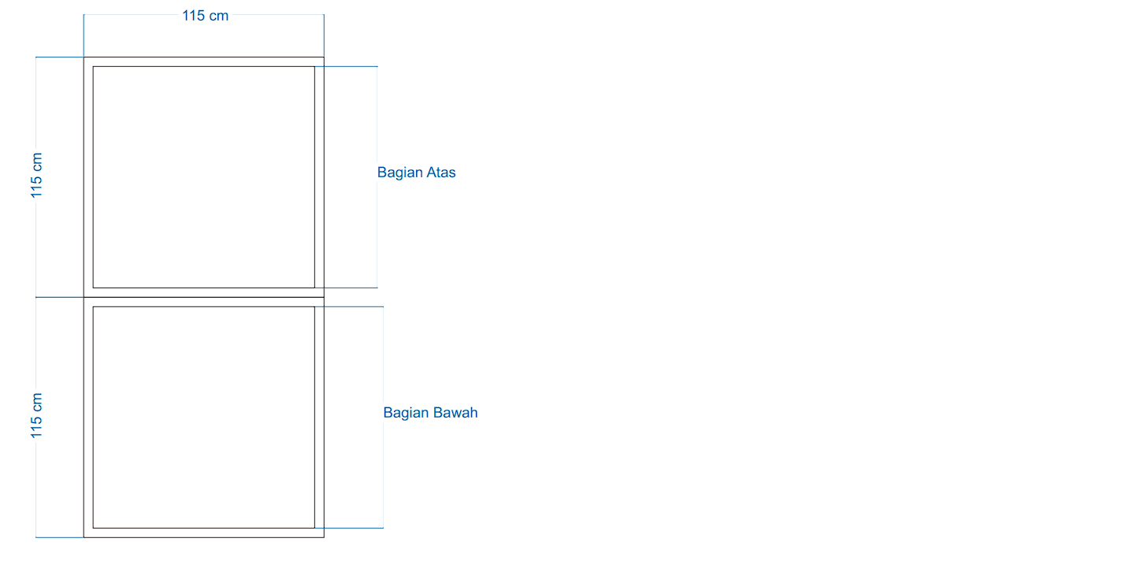

Gambar 2. Wooden Box ZOI Ilios 5000 Series Surgical Light - Double Dome dengan Hanging Monitor dan Built-in Camera

* 1. Corrugated Box Head Lamp ZOI Ilios 5000 Series Surgical Light - Double Dome dengan Hanging Monitor dan Built-in Camera #1
     + Bahan : Corrugated
     + Bentuk : Kotak
     + Warna : Coklat
     + Ukuran : 105 x 100 x 25 cm (p x l x t)

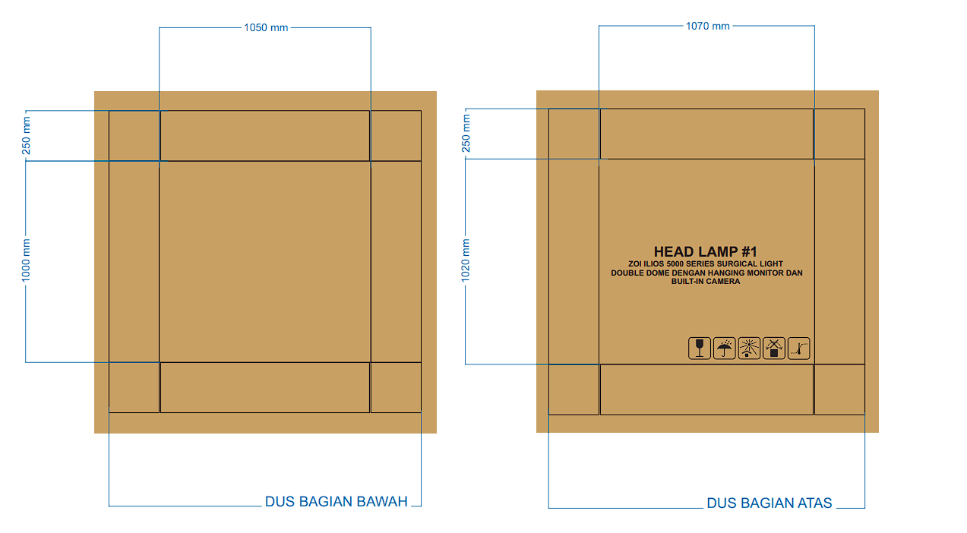

Gambar 3. Corrugated Box Head Lamp ZOI Ilios 5000 Series Surgical Light - Double Dome dengan Hanging Monitor dan Built-in Camera #1

* 1. Corrugated Box Head Lamp ZOI Ilios 5000 Series Surgical Light - Double Dome dengan Hanging Monitor dan Built-in Camera #2
     + Bahan : Corrugated
     + Bentuk : Kotak
     + Warna : Coklat
     + Ukuran : 105 x 100 x 25 cm (p x l x t)

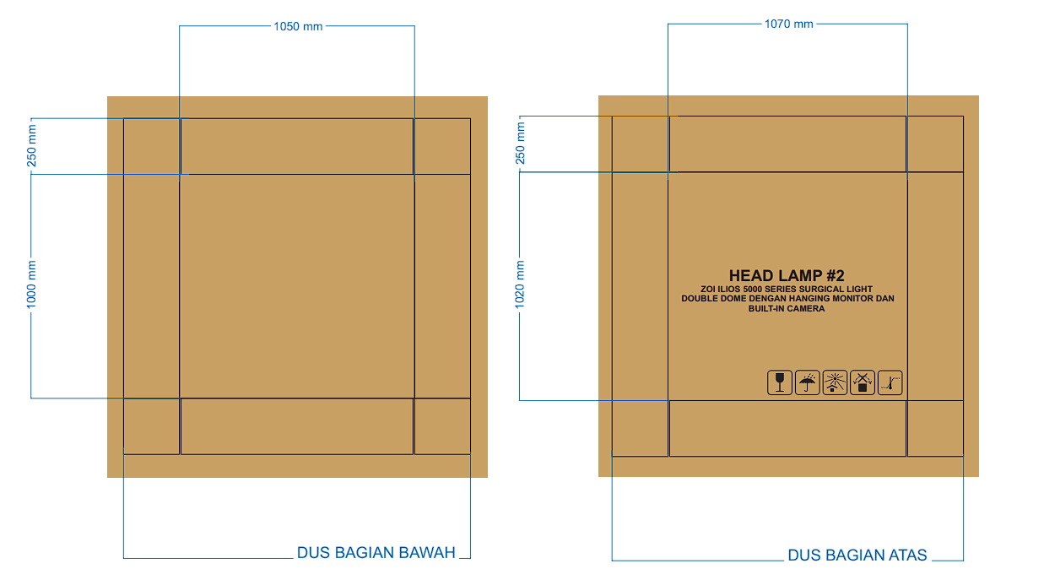

Gambar 4. Corrugated Box Head Lamp ZOI Ilios 5000 Series Surgical Light - Double Dome dengan Hanging Monitor dan Built-in Camera #2

* 1. Corrugated Box Operating Lamp Arm ZOI Ilios 5000 Series Surgical Light - Double Dome dengan Hanging Monitor dan Built-in Camera
     + Bahan : Corrugated
     + Bentuk : Kotak
     + Warna : Coklat
     + Ukuran : 105 x 16 x 45,5cm (p x l x t)

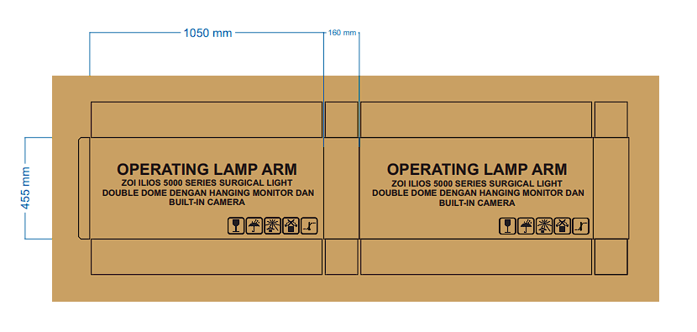

Gambar 5. Corrugated Box Operating Lamp Arm ZOI Ilios 5000 Series Surgical Light - Double Dome dengan Hanging Monitor dan Built-in Camera

* 1. Corrugated Box Aksesoris ZOI Ilios 5000 Series Surgical Light - Double Dome dengan Hanging Monitor dan Built-in Camera
     + Bahan : Corrugated
     + Bentuk : Kotak
     + Warna : Coklat
     + Ukuran : 56 x 31 x 21 cm (p x l x t)

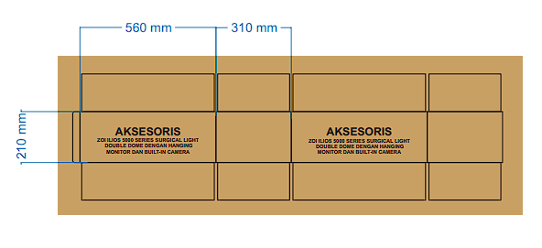

Gambar 6. Corrugated Box Aksesoris ZOI Ilios 5000 Series Surgical Light - Double Dome dengan Hanging Monitor dan Built-in Camera